

POLITECNICO DI MILANO

2016-2017

Software Engineering 2: PowerEnJoy

Integration Test Plan Document

Version 1.0

Peverelli Francesco

Reppucci Federico

**TABLE OF CONTENT**

|  |  |
| --- | --- |
| 1. INTRODUCTION  1.1 REVISION HISTORY  1.2 PUROPSE AND SCOPE  1.3 DEFINITIONS AND ABBREVIATIONS  1.4 REFERENCE DOCUMENTS  2. INTEGRATION STRATEGY  2.1 ENTRY CRITERIA  2.2 ELEMENTS TO INTEGRATE  2.3 INTEGRATN TESTING STRATEGY  2.4 COMPONENT-FUNCTION INTEGRATION  2.4.1. SYSTEM SERVER  2.4.2. CAR COMPONENT  2.4.3. USER APP INTEGRATION  2.4.4. EMPLOYEE APP INTEGRATION  2.4.5. SYSTEM INTEGRATION  3. INDIVIDUAL TESTS AND STEPS DESCRIPTION  4. TOOLS AND TEST EQUIPMENT REQUIRED  5. PROGRAM STUBS AND TEST DATA REQUIRED  6. EFFORT SPENT |  |

**1. INTRODUCTION**

***1.1 REVISION HISTORY***

***1.2 PUROPSE AND SCOPE***

Purpose

This documents describes a plan for the integration test for the system. In this document are specified the elements which need to be tested, the overall testing strategy, a brief description of all the tests to perform together with the objective of the test and the requirements to pass it. This document also contains a description of the testing tools to be employed in the testing process and eventual program stubs or specific test data that need to be produced. This document needs to be a reference for everyone who will contribute to the testing process.

Scope

The PowerEnJoy project aims to develop a car-sharing service run exclusively employing electric cars. The system will provide a mobile application by means of which the users, once registered, will be able to use the car sharing services. The main goals of the service are to provide a sustainable and environmentally-friendly car sharing service as well as to promote virtuous behaviors from its users.

***1.3 DEFINITIONS AND ABBREVIATIONS***

*Stub*: software module which substitutes a component or functionality

*Driver*: software module designed to stimulate another software component which needs to be tested

*J2EE*: Java 2 Enterprise Edition

*App*: mobile application

*External payment service*: a software system which allows the company to charge the users

*System:* ***TODO***

*System Server:* ***TODO***

***1.4 REFERENCE DOCUMENTS***

- The PowerEnJoy Requirements Analysis Specification Document (RASD)

- The PowerEnJoy Design Document (DD)

//TODO

**2. INTEGRATION STRATEGY**

***2.1 ENTRY CRITERIA***

Since this documents describes the integration test of all the single components, before a component can be integrated in the test plan all the unit-level tests need to be performed. The single component is required to provide all the interfaces described in the Design Document (DD) and these interfaces need to provide the expected functionality described during the design process. In addition, the interaction between the application server, the database and the client applications needs to be functioning properly.

***2.2 ELEMENTS TO INTEGRATE***

In this section the elements to be integrated are most of the components specified in the component diagram described in the design document.

System

- System component

- Car component

- user app component

- employee app component

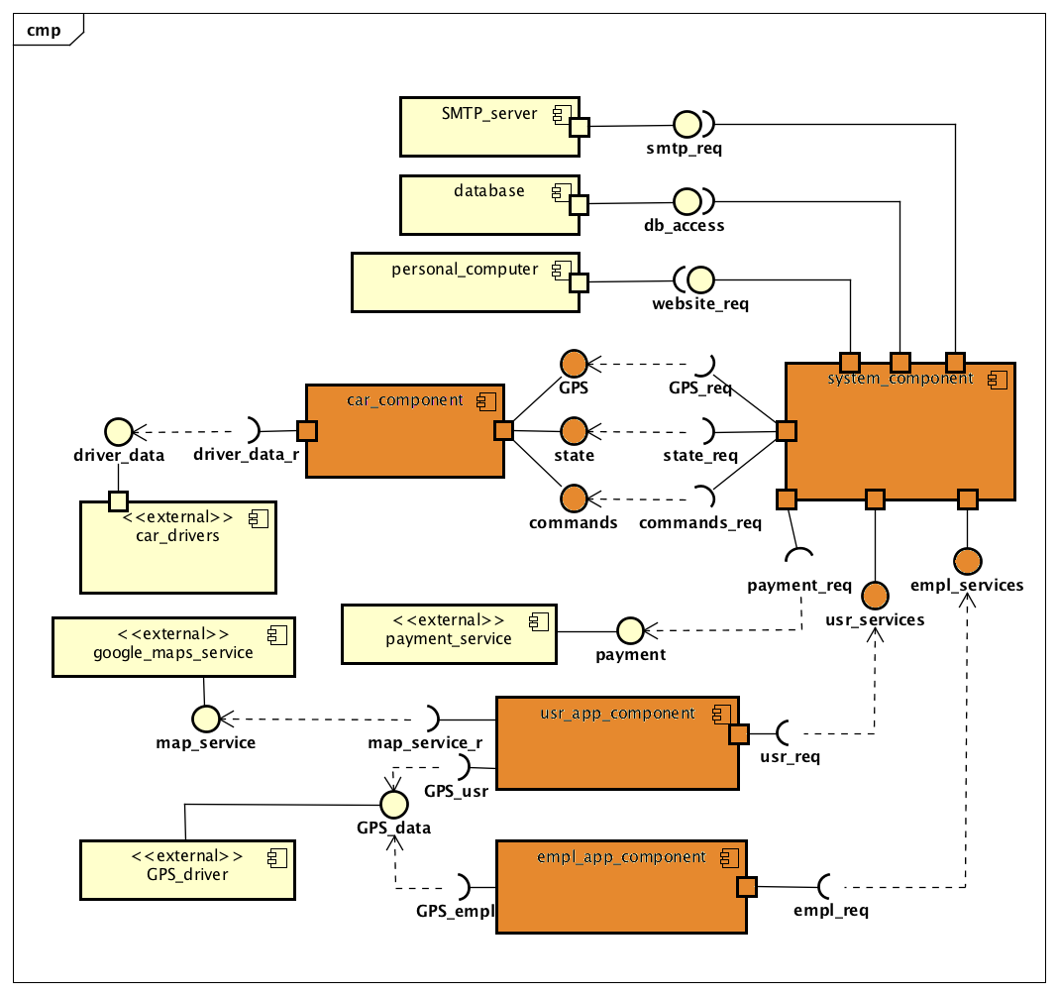

System component

- user registration controller

- active rides controller

- charges controller

- reservation controller

- car state controller

- car retrieval controller

- website controller

- user model

- charges history model

- reservation model

- car state model

- retrieval request model

- website model

- persistence unit

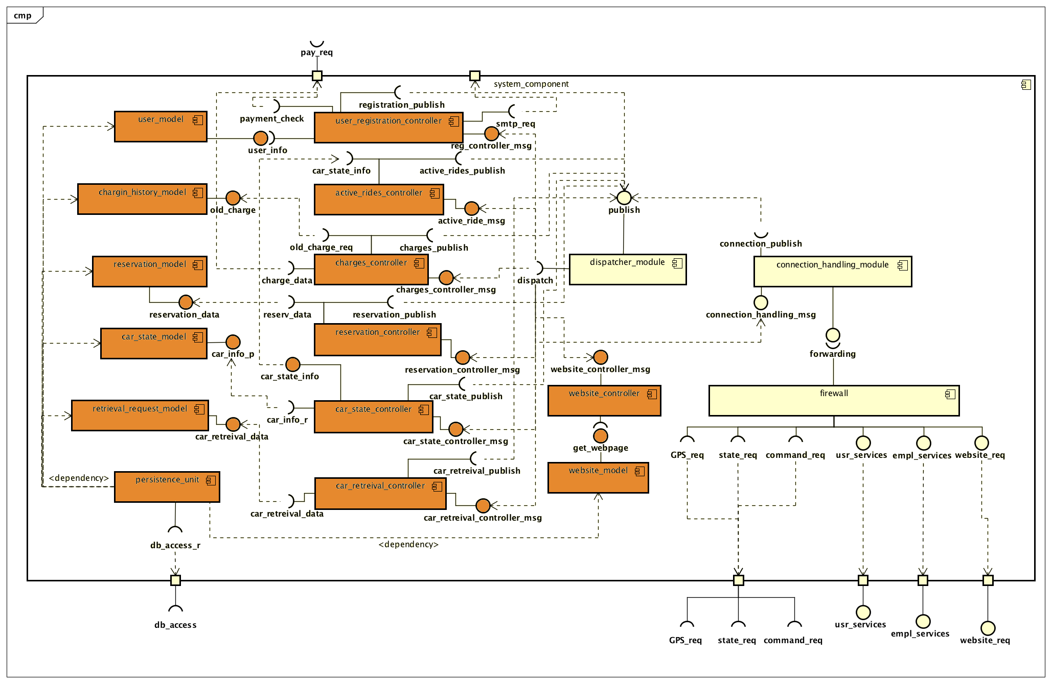

Car component

- terminal

- state wrapper

- command dispatcher

- locking command (?)

- GPS controller

- passengers’ sensor controller

- battery level controller

- locking state controller

- engine controller

- charging state

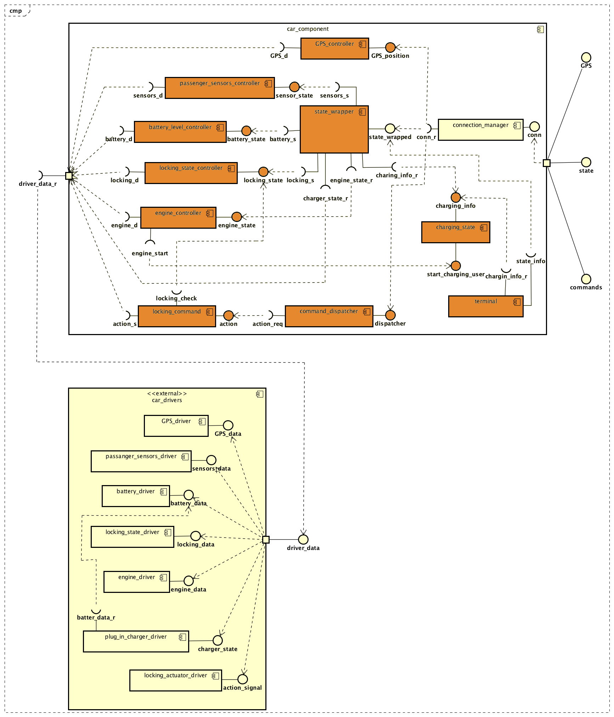

Employee app component

- user interface

- access manager

- retrieval manager

- unlock request manager

- push notification manager

- guest request manager

- authenticated request manager

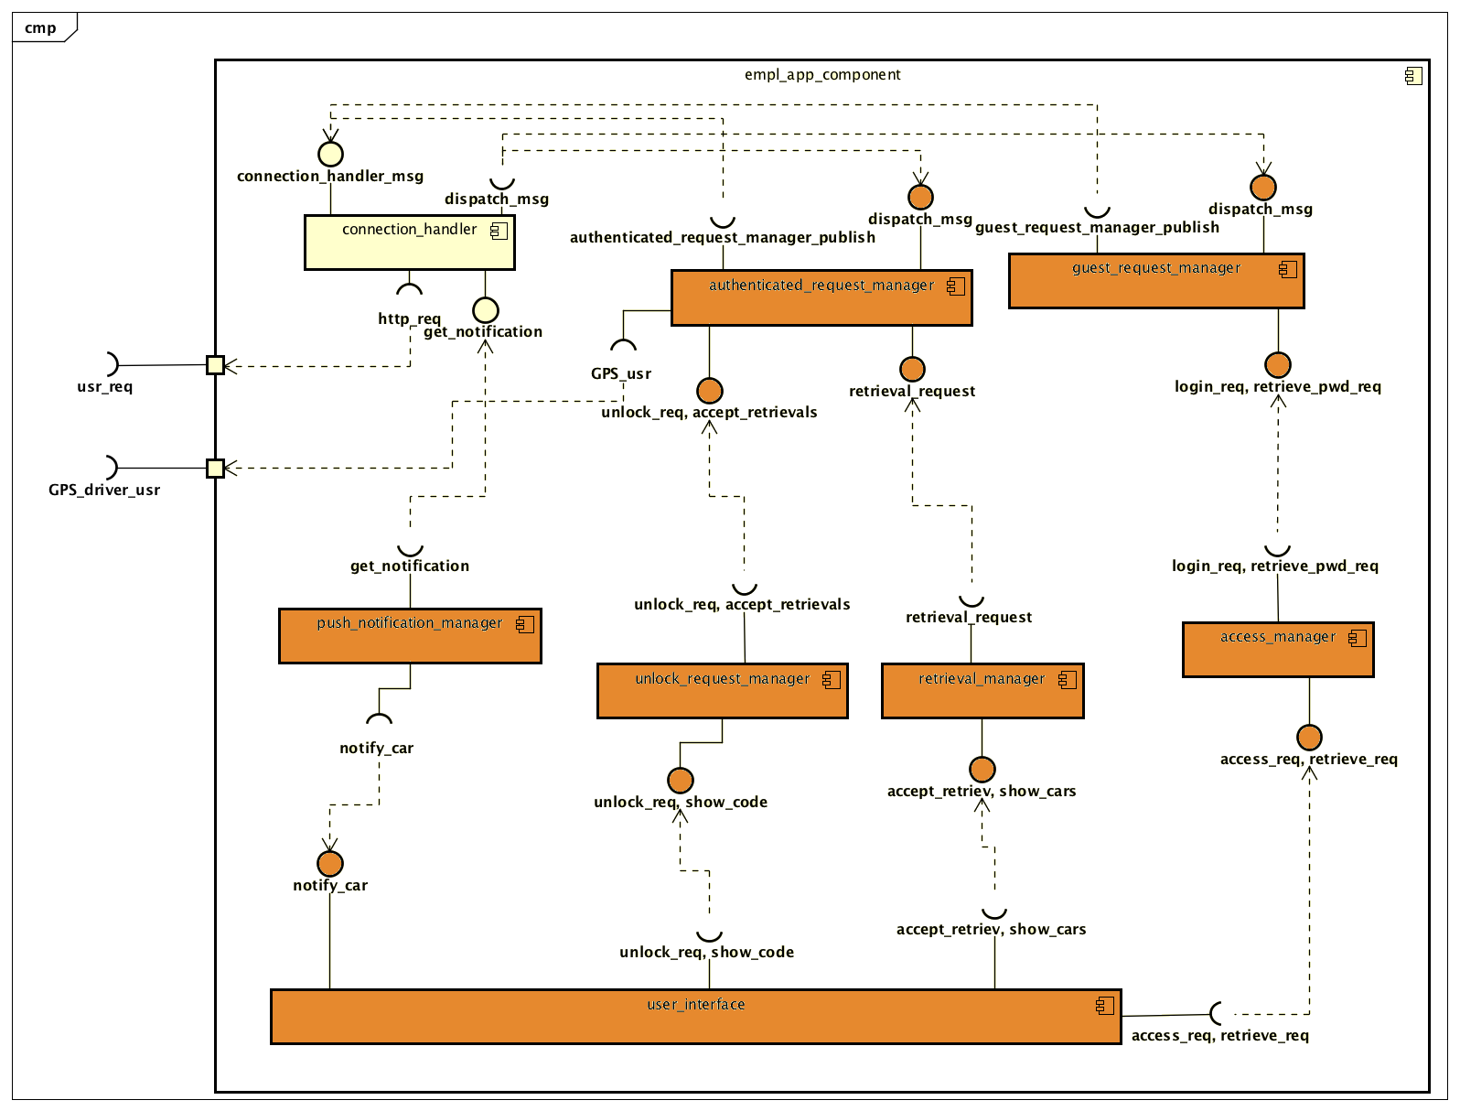

User app component

- user interface

- access manager

- registration manager

- profile manager

- reservation request manager

- unlock request manager

- map manager

- guest request manager

- authenticated request manager

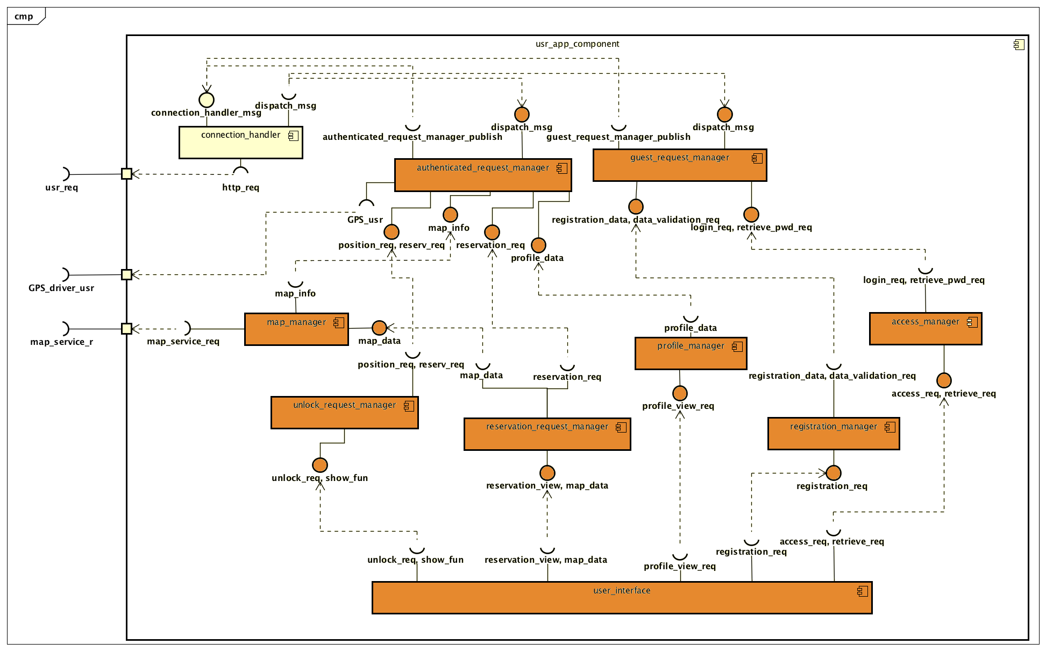

***2.3 INTEGRATN TESTING STRATEGY***

The testing strategy selected for the integration test is a bottom-up strategy. This strategy has been chosen since the structure of the software system is already hierarchical and the bottom-up approach allows to test all the interaction between components in a very systematic way. Moreover, the development process will follow a bottom-up approach as well, and this will ensure that the integration is performed in an incremental way.

***2.4 COMPONENT-FUNCTION INTEGRATION***

***2.4.1. SYSTEM SERVER***

Persistence-model integration

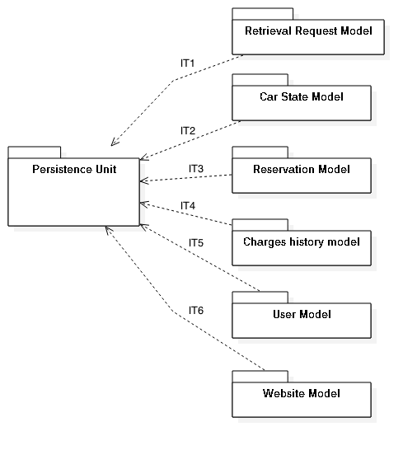

Model-controller integration

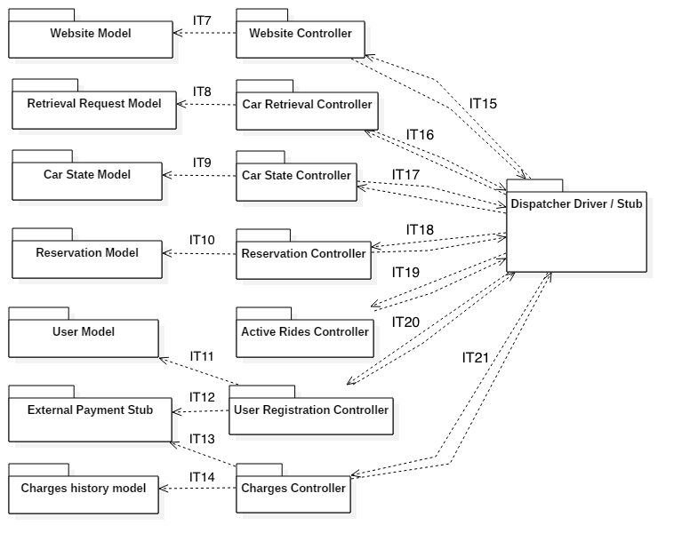

***2.4.2. CAR COMPONENT***

State wrapper – controller integration

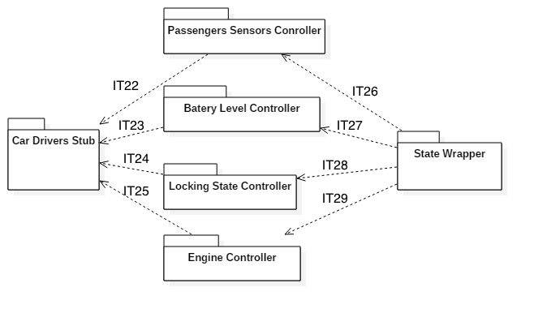

Command dispatcher - locking command integration

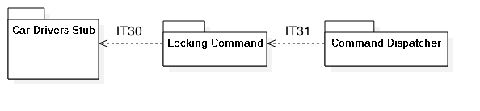

Charging state - terminal integration

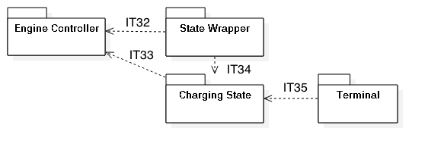

***2.4.3. USER APP INTEGRATION***

Request managers - functionality managers integration

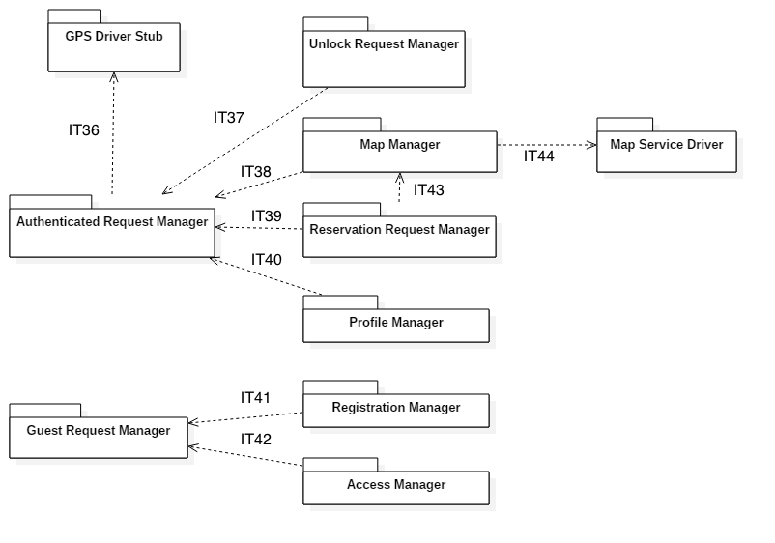

Functionality managers - user interface integration

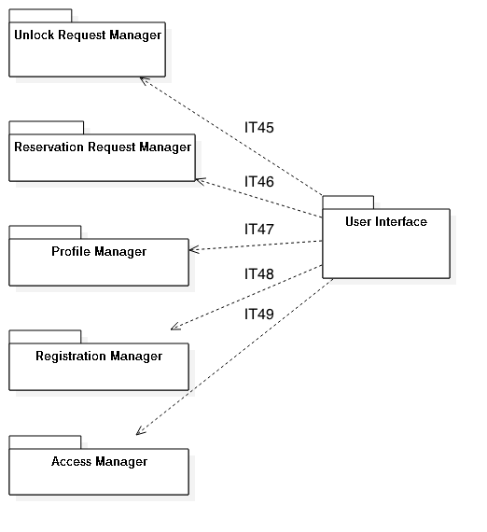

***2.4.4. EMPLOYEE APP INTEGRATION***

Request managers - functionality managers integration

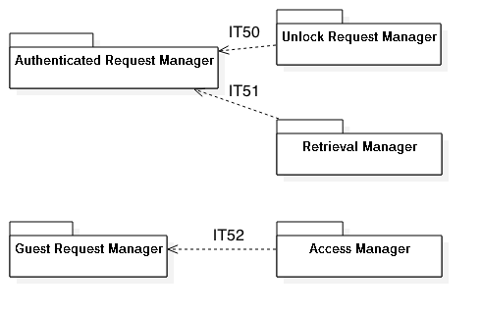

Functionality managers - user interface integration

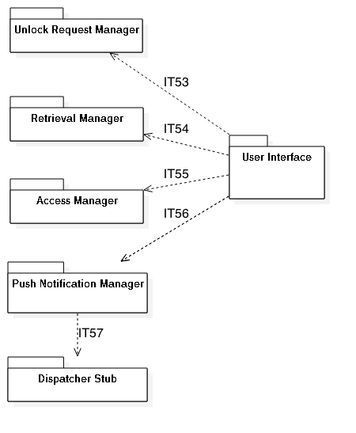

***2.4.5. SYSTEM INTEGRATION***

Subsystems

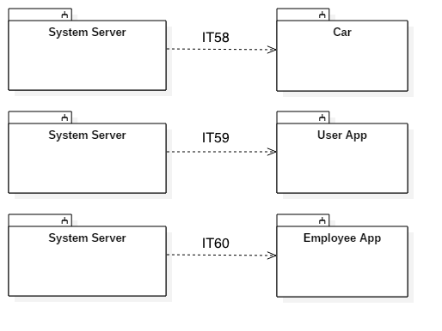

**3. INDIVIDUAL TESTS AND STEPS DESCRIPTION**

***3.1. PERSISTENCY UNIT INTEGRATION TEST (SYSTEM SERVER)***

|  |  |
| --- | --- |
| ***Test Case ID*** | IT1 |
| ***Test Item*** | Retrieval Request Model 🡪 Persistency Unit |
| ***Input Specification*** | Simulate *Persistency Unit* component typical input coming from *Retrieval Request Model*. |
| ***Output Specification*** | Check if the correct *Persistency Unit* methods are invoked in the correct way with respect to the input parameter values. |
| ***Environmental Needs*** | *Persistency Unit* component must have been already tested |

|  |  |
| --- | --- |
| ***Test Case ID*** | IT2 |
| ***Test Item*** | Car State Model 🡪 Persistency Unit |
| ***Input Specification*** | Simulate *Persistency Unit* component typical input coming from *Car State Model*. |
| ***Output Specification*** | Check if the correct *Persistency Unit* methods are invoked in the correct way with respect to the input parameter values. |
| ***Environmental Needs*** | *Persistency Unit* component must have been already tested |

|  |  |
| --- | --- |
| ***Test Case ID*** | IT3 |
| ***Test Item*** | Reservation Model 🡪 Persistency Unit |
| ***Input Specification*** | Simulate *Persistency Unit* component typical input coming from *Reservation Model*. |
| ***Output Specification*** | Check if the correct *Persistency Unit* methods are invoked in the correct way with respect to the input parameter values. |
| ***Environmental Needs*** | *Persistency Unit* component must have been already tested |

|  |  |
| --- | --- |
| ***Test Case ID*** | IT4 |
| ***Test Item*** | Charges History Model 🡪 Persistency Unit |
| ***Input Specification*** | Simulate *Persistency Unit* component typical input coming from *Charges History Model*. |
| ***Output Specification*** | Check if the correct *Persistency Unit* methods are invoked in the correct way with respect to the input parameter values. |
| ***Environmental Needs*** | *Persistency Unit* component must have been already tested |

|  |  |
| --- | --- |
| ***Test Case ID*** | IT5 |
| ***Test Item*** | User Model 🡪 Persistency Unit |
| ***Input Specification*** | Simulate *Persistency Unit* component typical input coming from *User Model*. |
| ***Output Specification*** | Check if the correct *Persistency Unit* methods are invoked in the correct way with respect to the input parameter values. |
| ***Environmental Needs*** | *Persistency Unit* component must have been already tested |

|  |  |
| --- | --- |
| ***Test Case ID*** | IT6 |
| ***Test Item*** | Website Model 🡪 Persistency Unit |
| ***Input Specification*** | Simulate *Persistency Unit* component typical input coming from *Website Model*. |
| ***Output Specification*** | Check if the correct *Persistency Unit* methods are invoked in the correct way with respect to the input parameter values. |
| ***Environmental Needs*** | *Persistency Unit* component must have been already tested |

***3.2. MODEL-CONTROLLER SYSTEM INTEGRATION TEST (SYSTEM SERVER)***

|  |  |
| --- | --- |
| ***Test Case ID*** | IT7 |
| ***Test Item*** | Website Controller 🡪 Website Model |
| ***Input Specification*** | Simulate *Website Model* component typical input coming from *Website Controller.* |
| ***Output Specification*** | Check if the correct *Website Controller* methods are invoked in the correct way with respect to the input parameter values. |
| ***Environmental Needs*** | *Website Controller* component must have been already tested. |

|  |  |
| --- | --- |
| ***Test Case ID*** | IT8 |
| ***Test Item*** | Car Retrieval Controller 🡪 Car Retrieval Model |
| ***Input Specification*** | Simulate *Car Retrieval Model* component typical input coming from *Car Retrieval Controller.* |
| ***Output Specification*** | Check if the correct Car *Retrieval Model* methods are invoked in the correct way with respect to the input parameter values. |
| ***Environmental Needs*** | *Car Retrieval Model* component must have been already tested. |

|  |  |
| --- | --- |
| ***Test Case ID*** | IT9 |
| ***Test Item*** | Car State Controller 🡪 Car State Model |
| ***Input Specification*** | Simulate *Car State Model*  component typical input coming from *Car State Controller* |
| ***Output Specification*** | Check if the correct *Car State Model* methods are invoked in the correct way with respect to the input parameter values. |
| ***Environmental Needs*** | *Car State Model* component must have been already tested. |

|  |  |
| --- | --- |
| ***Test Case ID*** | IT10 |
| ***Test Item*** | Reservation Controller 🡪 Reservation Model |
| ***Input Specification*** | Simulate *Reservation Model*  component typical input coming from *Reservation Controller.* |
| ***Output Specification*** | Check if the correct Re*servation Model* methods are invoked in the correct way with respect to the input parameter values. |
| ***Environmental Needs*** | *Reservation Model* component must have been already tested. |

|  |  |
| --- | --- |
| ***Test Case ID*** | IT11 |
| ***Test Item*** | User Registration Controller 🡪 User Model |
| ***Input Specification*** | Simulate *User Registration Model*  component typical input coming from *User Registration Controller.* |
| ***Output Specification*** | Check if the correct *User Registration Model* methods are invoked in the correct way with respect to the input parameter values. |
| ***Environmental Needs*** | *User Registration Model* component must have been already tested. |

|  |  |
| --- | --- |
| ***Test Case ID*** | IT12 |
| ***Test Item*** | User Registration Controller 🡪 External Payment Stub |
| ***Input Specification*** | Simulate *External Payment Stub*  component typical input coming from *User Registration Controller.* |
| ***Output Specification*** | Check if the correct *External Payment Stub* methods are invoked in the correct way with respect to the input parameter values. |
| ***Environmental Needs*** | *External Payment Stub* must have been already tested. |

|  |  |
| --- | --- |
| ***Test Case ID*** | IT13 |
| ***Test Item*** | Charges Controller 🡪 External Payment Stub |
| ***Input Specification*** | Simulate *External Payment Stub* typical input coming from *Charges Controller.* |
| ***Output Specification*** | Check if the correct *External Payment Stub* methods are invoked in the correct way with respect to the input parameter values. |
| ***Environmental Needs*** | *External Payment Stub* must have been already tested. |

|  |  |
| --- | --- |
| ***Test Case ID*** | IT14 |
| ***Test Item*** | Charges Controller 🡪 Charges History Model |
| ***Input Specification*** | Simulate *Charges History Model*  component typical input coming from *Charges Controller.* |
| ***Output Specification*** | Check if the correct *Charges History Model* methods are invoked in the correct way with respect to the input parameter values. |
| ***Environmental Needs*** | *Charges History Model* component must have been already tested. |

***3.3. MODEL-CONTROLLER SYSTEM INTEGRATION TEST (SYSTEM SERVER)***

|  |  |
| --- | --- |
| ***Test Case ID*** | IT15-1 |
| ***Test Item*** | Website Controller 🡪 Dispatcher Stub |
| ***Input Specification*** | Simulate *Dispatcher Stub* typical input coming from *Website Controller* |
| ***Output Specification*** | Check if the correct *Dispatcher Stub* methods are invoked in the correct way with respect to the input parameter values. |
| ***Environmental Needs*** | *Dispatcher Stub* must have been already tested. |

|  |  |
| --- | --- |
| ***Test Case ID*** | IT15-2 |
| ***Test Item*** | Dispatcher Driver 🡪 Website Controller |
| ***Input Specification*** | Simulate *Website Controller* component typical input coming from *Dispatcher Driver* |
| ***Output Specification*** | Check if the correct *Website Controller* methods are invoked in the correct way with respect to the input parameter values. |
| ***Environmental Needs*** | *Website Controller* component must have been already tested. |

|  |  |
| --- | --- |
| ***Test Case ID*** | IT16-1 |
| ***Test Item*** | Car Retrieval Controller 🡪 Dispatcher Stub |
| ***Input Specification*** | Simulate *Dispatcher Stub*  component typical input coming from *Car Retrieval Controller.* |
| ***Output Specification*** | Check if the correct *Dispatcher Stub*  methods are invoked in the correct way with respect to the input parameter values. |
| ***Environmental Needs*** | *Dispatcher Stub* must have been already tested. |

|  |  |
| --- | --- |
| ***Test Case ID*** | IT16-2 |
| ***Test Item*** | Dispatcher Driver 🡪 Car Retrieval Controller |
| ***Input Specification*** | Simulate *Car Retrieval Controller*  component typical input coming from *Dispatcher Driver* |
| ***Output Specification*** | Check if the correct *Car Retrieval Controller* methods are invoked in the correct way with respect to the input parameter values. |
| ***Environmental Needs*** | *Car Retrieval Controller* component must have been already tested. |

|  |  |
| --- | --- |
| ***Test Case ID*** | IT17-1 |
| ***Test Item*** | Car State Controller 🡪 Dispatcher Stub |
| ***Input Specification*** | Simulate *Dispatcher Stub*  component typical input coming from *Car State Controller* |
| ***Output Specification*** | Check if the correct *Dispatcher Stub*  methods are invoked in the correct way with respect to the input parameter values. |
| ***Environmental Needs*** | *Dispatcher Stub* must have been already tested. |

|  |  |
| --- | --- |
| ***Test Case ID*** | IT17-2 |
| ***Test Item*** | Dispatcher Driver 🡪 Car State Controller |
| ***Input Specification*** | Simulate *Car State Controller* component typical input coming from *Dispatcher Driver* |
| ***Output Specification*** | Check if the correct *Car State Controller* methods are invoked in the correct way with respect to the input parameter values. |
| ***Environmental Needs*** | *Car State Controller* component must have been already tested. |

|  |  |
| --- | --- |
| ***Test Case ID*** | IT18-1 |
| ***Test Item*** | Reservation Controller 🡪 Dispatcher Stub |
| ***Input Specification*** | Simulate *Dispatcher Stub*  component typical input coming from *Reservation Controller* |
| ***Output Specification*** | Check if the correct *Dispatcher Stub*  methods are invoked in the correct way with respect to the input parameter values. |
| ***Environmental Needs*** | *Dispatcher Stub* must have been already tested. |

|  |  |
| --- | --- |
| ***Test Case ID*** | IT18-2 |
| ***Test Item*** | Dispatcher Driver 🡪 Reservation Controller |
| ***Input Specification*** | Simulate *Reservation Controller* component typical input coming from *Dispatcher Driver* |
| ***Output Specification*** | Check if the correct *Reservation Controller* methods are invoked in the correct way with respect to the input parameter values. |
| ***Environmental Needs*** | *Reservation Controller* component must have been already tested. |

|  |  |
| --- | --- |
| ***Test Case ID*** | IT19-1 |
| ***Test Item*** | Active Rides Controller 🡪 Dispatcher Stub |
| ***Input Specification*** | Simulate *Dispatcher Stub*  component typical input coming from *Active Rides Controller* |
| ***Output Specification*** | Check if the correct *Dispatcher Stub*  methods are invoked in the correct way with respect to the input parameter values. |
| ***Environmental Needs*** | *Dispatcher Stub* must have been already tested. |

|  |  |
| --- | --- |
| ***Test Case ID*** | IT19-2 |
| ***Test Item*** | Dispatcher Driver 🡪 Active Rides Controller |
| ***Input Specification*** | Simulate *Active Rides Controller* component typical input coming from *Dispatcher Driver* |
| ***Output Specification*** | Check if the correct *Active Rides Controller* methods are invoked in the correct way with respect to the input parameter values. |
| ***Environmental Needs*** | *Active Rides Controller* component must have been already tested. |

|  |  |
| --- | --- |
| ***Test Case ID*** | IT20-1 |
| ***Test Item*** | User Registration Controller 🡪 Dispatcher Stub |
| ***Input Specification*** | Simulate *Dispatcher Stub*  component typical input coming from *User Registration Controller* |
| ***Output Specification*** | Check if the correct *Dispatcher Stub*  methods are invoked in the correct way with respect to the input parameter values. |
| ***Environmental Needs*** | *Dispatcher Stub* must have been already tested. |

|  |  |
| --- | --- |
| ***Test Case ID*** | IT20-2 |
| ***Test Item*** | Dispatcher Driver 🡪 User Registration Controller |
| ***Input Specification*** | Simulate *User Registration Controller* component typical input coming from *Dispatcher Driver* |
| ***Output Specification*** | Check if the correct *User Registration Controller* methods are invoked in the correct way with respect to the input parameter values. |
| ***Environmental Needs*** | *User Registration Controller* component must have been already tested. |

|  |  |
| --- | --- |
| ***Test Case ID*** | IT21-1 |
| ***Test Item*** | Charges Controller 🡪 Dispatcher Stub |
| ***Input Specification*** | Simulate *Dispatcher Stub*  component typical input coming from *Charges Controller* |
| ***Output Specification*** | Check if the correct *Dispatcher Stub*  methods are invoked in the correct way with respect to the input parameter values. |
| ***Environmental Needs*** | *Dispatcher Stub* must have been already tested. |

|  |  |
| --- | --- |
| ***Test Case ID*** | IT21-2 |
| ***Test Item*** | Dispatcher Driver 🡪 Charges Controller |
| ***Input Specification*** | Simulate *Charges Controller* component typical input coming from *Dispatcher Driver* |
| ***Output Specification*** | Check if the correct *Charges Controller* methods are invoked in the correct way with respect to the input parameter values. |
| ***Environmental Needs*** | *Charges Controller* component must have been already tested. |

***3.4. STATE WRAPPER-CONTROLLER INTEGRATION TEST (CAR)***

|  |  |
| --- | --- |
| ***Test Case ID*** | IT22 |
| ***Test Item*** | Passengers Sensors Controller 🡪 Car Drivers Stub |
| ***Input Specification*** | Simulate *Car Drivers Stub*  component typical input coming from *Passengers Sensors Controller.* |
| ***Output Specification*** | Check if the correct *Car Drivers Stub* methods are invoked in the correct way with respect to the input parameter values. |
| ***Environmental Needs*** | *Car Drivers Stub* must have been already tested. |

|  |  |
| --- | --- |
| ***Test Case ID*** | IT23 |
| ***Test Item*** | Battery Level Controller 🡪 Car Drivers Stub |
| ***Input Specification*** | Simulate *Car Drivers Stub* typical input coming from *Battery Level Controller* |
| ***Output Specification*** | Check if the correct *Car Drivers Stub* methods are invoked in the correct way with respect to the input parameter values. |
| ***Environmental Needs*** | *Car Drivers Stub* must have been already tested. |

|  |  |
| --- | --- |
| ***Test Case ID*** | IT24 |
| ***Test Item*** | Locking State Controller 🡪 Car Drivers Stub |
| ***Input Specification*** | Simulate *Car Drivers Stub* typical input coming from *Locking State Controller* |
| ***Output Specification*** | Check if the correct *Car Drivers Stub* methods are invoked in the correct way with respect to the input parameter values. |
| ***Environmental Needs*** | *Car Drivers Stub* must have been already tested. |

|  |  |
| --- | --- |
| ***Test Case ID*** | IT25 |
| ***Test Item*** | Engine Controller 🡪 Car Drivers Stub |
| ***Input Specification*** | Simulate *Car Drivers Stub* typical input coming from *Engine Controller* |
| ***Output Specification*** | Check if the correct *Car Drivers Stub* methods are invoked in the correct way with respect to the input parameter values. |
| ***Environmental Needs*** | *Car Drivers Stub* must have been already tested. |

|  |  |
| --- | --- |
| ***Test Case ID*** | IT26 |
| ***Test Item*** | State Wrapper 🡪 Passengers Sensors Controller |
| ***Input Specification*** | Simulate *Passengers Sensors Controller*  component typical input coming from *State Wrapper* |
| ***Output Specification*** | Check if the correct *Passengers Sensors Controller* methods are invoked in the correct way with respect to the input parameter values. |
| ***Environmental Needs*** | *Passengers Sensors Controller* must have been already tested. |

|  |  |
| --- | --- |
| ***Test Case ID*** | IT27 |
| ***Test Item*** | State Wrapper 🡪 Battery Level Controller |
| ***Input Specification*** | Simulate *Battery Level Controller*  component typical input coming from *State Wrapper* |
| ***Output Specification*** | Check if the correct *Battery Level Controller* methods are invoked in the correct way with respect to the input parameter values. |
| ***Environmental Needs*** | *Battery Level Controller* component must have been already tested. |

|  |  |
| --- | --- |
| ***Test Case ID*** | IT28 |
| ***Test Item*** | State Wrapper 🡪 Locking State Controller |
| ***Input Specification*** | Simulate *Locking State Controller*  component typical input coming from *State Wrapper* |
| ***Output Specification*** | Check if the correct *Locking State Controller* methods are invoked in the correct way with respect to the input parameter values. |
| ***Environmental Needs*** | *Locking State Controller* component must have been already tested. |

|  |  |
| --- | --- |
| ***Test Case ID*** | IT29 |
| ***Test Item*** | State Wrapper 🡪 Engine Controller |
| ***Input Specification*** | Simulate *Engine Controller*  component typical input coming from *State Wrapper* |
| ***Output Specification*** | Check if the correct *Engine Controller* methods are invoked in the correct way with respect to the input parameter values. |
| ***Environmental Needs*** | *Engine Controller* component must have been already tested. |

***3.5. COMMAND DISPATCHER – LOCKING COMMAND INTEGRATION TEST (CAR)***

|  |  |
| --- | --- |
| ***Test Case ID*** | IT30 |
| ***Test Item*** | Locking Command 🡪 Car Drivers Stub |
| ***Input Specification*** | Simulate *Car Drivers Stub* typical input coming from *Locking Command* |
| ***Output Specification*** | Check if the correct *Car Drivers Stub* methods are invoked in the correct way with respect to the input parameter values. |
| ***Environmental Needs*** | *Car Drivers Stub* must have been already tested. |

|  |  |
| --- | --- |
| ***Test Case ID*** | IT31 |
| ***Test Item*** | Command Dispatcher 🡪 Locking Command |
| ***Input Specification*** | Simulate *Locking Command*  component typical input coming from *Command Dispatcher.* |
| ***Output Specification*** | Check if the correct *Locking Command* methods are invoked in the correct way with respect to the input parameter values. |
| ***Environmental Needs*** | *Locking Command* component must have been already tested. |

***3.6. CHARGING STATE – TERMINAL INTEGRATION TEST (CAR)***

|  |  |
| --- | --- |
| ***Test Case ID*** | IT32 |
| ***Test Item*** | State Wrapper 🡪 Engine Controller |
| ***Input Specification*** | Simulate *Engine Controller*  component typical input coming from *State Wrapper* |
| ***Output Specification*** | Check if the correct *Engine Controller* methods are invoked in the correct way with respect to the input parameter values. |
| ***Environmental Needs*** | *Engine Controller* component must have been already tested. |

|  |  |
| --- | --- |
| ***Test Case ID*** | IT33 |
| ***Test Item*** | Charging State 🡪 Engine Controller |
| ***Input Specification*** | Simulate *Engine Controller*  component typical input coming from *Charging State.* |
| ***Output Specification*** | Check if the correct *Engine Controller* methods are invoked in the correct way with respect to the input parameter values. |
| ***Environmental Needs*** | *Engine Controller* component must have been already tested. |

|  |  |
| --- | --- |
| ***Test Case ID*** | IT34 |
| ***Test Item*** | State Wrapper 🡪 Charging State |
| ***Input Specification*** | Simulate *Charging State*  component typical input coming from *State Wrapper.* |
| ***Output Specification*** | Check if the correct *Charging State*  methods are invoked in the correct way with respect to the input parameter values. |
| ***Environmental Needs*** | *Charging State*  component must have been already tested. |

|  |  |
| --- | --- |
| ***Test Case ID*** | IT35 |
| ***Test Item*** | Terminal 🡪 Charging State |
| ***Input Specification*** | Simulate *Charging State*  component typical input coming from *Terminal.* |
| ***Output Specification*** | Check if the correct *Charging State*  methods are invoked in the correct way with respect to the input parameter values. |
| ***Environmental Needs*** | *Charging State*  component must have been already tested. |

***3.7. REQUEST MANAGERS – FUNCIONALITY MANAGERS INTEGRATION TEST (USER APP)***

|  |  |
| --- | --- |
| ***Test Case ID*** | IT36 |
| ***Test Item*** | Authenticated Request Manager 🡪 GPS Driver Stub |
| ***Input Specification*** | Simulate *GPS Driver Stub* component typical input coming from *Authenticated Request Manager.* |
| ***Output Specification*** | Check if the correct *GPS Driver Stub* methods are invoked in the correct way with respect to the input parameter values. |
| ***Environmental Needs*** | *GPS Driver Stub* component must have been already tested. |

|  |  |
| --- | --- |
| ***Test Case ID*** | IT37 |
| ***Test Item*** | Unlock Request Manager 🡪 Authenticated Request Manager |
| ***Input Specification*** | Simulate *Authenticated Request Manager* component typical input coming from *Unlock Request Manager* |
| ***Output Specification*** | Check if the correct *Authenticated Request Manager* methods are invoked in the correct way with respect to the input parameter values. |
| ***Environmental Needs*** | *Authenticated Request Manager* component must have been already tested. |

|  |  |
| --- | --- |
| ***Test Case ID*** | IT38 |
| ***Test Item*** | Map Manager 🡪 Authenticated Request Manager |
| ***Input Specification*** | Simulate *Authenticated Request Manager* component typical input coming from *Map Manager* |
| ***Output Specification*** | Check if the correct *Authenticated Request Manager* methods are invoked in the correct way with respect to the input parameter values. |
| ***Environmental Needs*** | *Authenticated Request Manager* component must have been already tested. |

|  |  |
| --- | --- |
| ***Test Case ID*** | IT39 |
| ***Test Item*** | Reservation Request Manager 🡪 Authenticated Request Manager |
| ***Input Specification*** | Simulate *Authenticated Request Manager* component typical input coming from *Reservation Request Manager* |
| ***Output Specification*** | Check if the correct *Authenticated Request Manager* methods are invoked in the correct way with respect to the input parameter values. |
| ***Environmental Needs*** | *Authenticated Request Manager* component must have been already tested. |

|  |  |
| --- | --- |
| ***Test Case ID*** | IT40 |
| ***Test Item*** | Profile Manager 🡪 Authenticated Request Manager |
| ***Input Specification*** | Simulate *Authenticated Request Manager* component typical input coming from *Profile Manager* |
| ***Output Specification*** | Check if the correct *Authenticated Request Manager* methods are invoked in the correct way with respect to the input parameter values. |
| ***Environmental Needs*** | *Authenticated Request Manager* component must have been already tested. |

|  |  |
| --- | --- |
| ***Test Case ID*** | IT41 |
| ***Test Item*** | Registration Manager 🡪 Guest Request Manager |
| ***Input Specification*** | Simulate *Guest Request Manager* component typical input coming from *Registration Manager* |
| ***Output Specification*** | Check if the correct *Guest Request Manager* methods are invoked in the correct way with respect to the input parameter values. |
| ***Environmental Needs*** | *Guest Request Manager* component must have been already tested. |

|  |  |
| --- | --- |
| ***Test Case ID*** | IT42 |
| ***Test Item*** | Access Manager 🡪 Guest Request Manager |
| ***Input Specification*** | Simulate *Guest Request Manager* component typical input coming from *Access Manager* |
| ***Output Specification*** | Check if the correct *Guest Request Manager* methods are invoked in the correct way with respect to the input parameter values. |
| ***Environmental Needs*** | *Guest Request Manager* component must have been already tested. |

|  |  |
| --- | --- |
| ***Test Case ID*** | IT43 |
| ***Test Item*** | Reservation Request Manager 🡪 Map Manager |
| ***Input Specification*** | Simulate *Map Manager* component typical input coming from *Reservation Request Manager* |
| ***Output Specification*** | Check if the correct *Map Manager* methods are invoked in the correct way with respect to the input parameter values. |
| ***Environmental Needs*** | *Map Manager* component must have been already tested. |

|  |  |
| --- | --- |
| ***Test Case ID*** | IT44 |
| ***Test Item*** | Map Manager 🡪 Map Service Driver |
| ***Input Specification*** | Simulate *Map Service Driver* component typical input coming from *Map Manager* |
| ***Output Specification*** | Check if the correct *Map Service Driver* methods are invoked in the correct way with respect to the input parameter values. |
| ***Environmental Needs*** | *Map Service Driver* component must have been already tested. |

***3.8. FUNCTIONALITY MANAGERS – USER INTERFACE INTEGRATION TEST (USER APP)***

|  |  |
| --- | --- |
| ***Test Case ID*** | IT45 |
| ***Test Item*** | User Interface 🡪 Unlock Request Manager |
| ***Input Specification*** | Simulate *Unlock Request Manager* component typical input coming from *User Interface* |
| ***Output Specification*** | Check if the correct *Unlock Request Manager* methods are invoked in the correct way with respect to the input parameter values. |
| ***Environmental Needs*** | *Unlock Request Manager* component must have been already tested. |

|  |  |
| --- | --- |
| ***Test Case ID*** | IT46 |
| ***Test Item*** | User Interface 🡪 Reservation Request Manager |
| ***Input Specification*** | Simulate *Reservation Request Manager* component typical input coming from *User Interface* |
| ***Output Specification*** | Check if the correct *Reservation Request Manager* methods are invoked in the correct way with respect to the input parameter values. |
| ***Environmental Needs*** | *Reservation Request Manager* component must have been already tested. |

|  |  |
| --- | --- |
| ***Test Case ID*** | IT47 |
| ***Test Item*** | User Interface 🡪 Profile Manager |
| ***Input Specification*** | Simulate *Profile Manager* component typical input coming from *User Interface* |
| ***Output Specification*** | Check if the correct *Profile Manager* methods are invoked in the correct way with respect to the input parameter values. |
| ***Environmental Needs*** | *Profile Manager* component must have been already tested. |

|  |  |
| --- | --- |
| ***Test Case ID*** | IT48 |
| ***Test Item*** | User Interface 🡪 Registration Manager |
| ***Input Specification*** | Simulate *Registration Manager* component typical input coming from *User Interface* |
| ***Output Specification*** | Check if the correct *Registration Manager* methods are invoked in the correct way with respect to the input parameter values. |
| ***Environmental Needs*** | *Registration Manager* component must have been already tested. |

|  |  |
| --- | --- |
| ***Test Case ID*** | IT49 |
| ***Test Item*** | User Interface 🡪 Access Manager |
| ***Input Specification*** | Simulate *Access Manager* component typical input coming from *User Interface* |
| ***Output Specification*** | Check if the correct *Access Manager* methods are invoked in the correct way with respect to the input parameter values. |
| ***Environmental Needs*** | *Access Manager* component must have been already tested. |

***3.10. REQUEST MANAGERS – FUNCIONALITY MANAGERS (EMPLOYEE APP)***

|  |  |
| --- | --- |
| ***Test Case ID*** | IT50 |
| ***Test Item*** | Unlock Request Manager 🡪 Authenticated Request Manager |
| ***Input Specification*** | Simulate *Authenticated Request Manager* component typical input coming from *Unlock Request Manager* |
| ***Output Specification*** | Check if the correct *Authenticated Request Manager* methods are invoked in the correct way with respect to the input parameter values. |
| ***Environmental Needs*** | *Authenticated Request Manager* component must have been already tested. |

|  |  |
| --- | --- |
| ***Test Case ID*** | IT51 |
| ***Test Item*** | Retrieval Manager 🡪 Authenticated Request Manager |
| ***Input Specification*** | Simulate *Authenticated Request Manager* component typical input coming from *Retrieval Manager* |
| ***Output Specification*** | Check if the correct *Authenticated Request Manager* methods are invoked in the correct way with respect to the input parameter values. |
| ***Environmental Needs*** | *Authenticated Request Manager* component must have been already tested. |

|  |  |
| --- | --- |
| ***Test Case ID*** | IT52 |
| ***Test Item*** | Access Manager 🡪 Guest Request Manager |
| ***Input Specification*** | Simulate *Guest Request Manager* component typical input coming from *Access Manager* |
| ***Output Specification*** | Check if the correct *Guest Request Manager* methods are invoked in the correct way with respect to the input parameter values. |
| ***Environmental Needs*** | *Guest Request Manager* component must have been already tested. |

***3.11. FUNCIONALITY MANAGER – USER INTERFACE INTEGRATION TEST (EMPLOYEE APP)***

|  |  |
| --- | --- |
| ***Test Case ID*** | IT53 |
| ***Test Item*** | User Interface 🡪 Unlock Request Manager |
| ***Input Specification*** | Simulate *Unlock Request Manager* component typical input coming from *User Interface* |
| ***Output Specification*** | Check if the correct *Unlock Request Manager* methods are invoked in the correct way with respect to the input parameter values. |
| ***Environmental Needs*** | *Unlock Request Manager* component must have been already tested. |

|  |  |
| --- | --- |
| ***Test Case ID*** | IT54 |
| ***Test Item*** | User Interface 🡪 Retrieval Manager |
| ***Input Specification*** | Simulate *Retrieval Manager* component typical input coming from *User Interface* |
| ***Output Specification*** | Check if the correct *Retrieval Manager* methods are invoked in the correct way with respect to the input parameter values. |
| ***Environmental Needs*** | *Retrieval Manager* component must have been already tested. |

|  |  |
| --- | --- |
| ***Test Case ID*** | IT55 |
| ***Test Item*** | User Interface 🡪 Access Manager |
| ***Input Specification*** | Simulate *Access Manager* component typical input coming from *User Interface* |
| ***Output Specification*** | Check if the correct *Access Manager* methods are invoked in the correct way with respect to the input parameter values. |
| ***Environmental Needs*** | *Access Manager* component must have been already tested. |

|  |  |
| --- | --- |
| ***Test Case ID*** | IT56 |
| ***Test Item*** | User Interface 🡪 Push Notification Center |
| ***Input Specification*** | Simulate *Push Notification Center* component typical input coming from *User Interface* |
| ***Output Specification*** | Check if the correct *Push Notification Center* methods are invoked in the correct way with respect to the input parameter values. |
| ***Environmental Needs*** | *Push Notification Center* component must have been already tested. |

|  |  |
| --- | --- |
| ***Test Case ID*** | IT57 |
| ***Test Item*** | Push Notification Center 🡪 Dispatcher Stub |
| ***Input Specification*** | Simulate *Dispatcher Stub* component typical input coming from *Push Notification Center* |
| ***Output Specification*** | Check if the correct *Dispatcher Stub* methods are invoked in the correct way with respect to the input parameter values. |
| ***Environmental Needs*** | *Dispatcher Stub* component must have been already tested. |

***3.12. SUBSYSTEMS INTEGRATION TEST***

|  |  |
| --- | --- |
| ***Test Case ID*** | IT58 |
| ***Test Item*** | System Server 🡪 Car |
| ***Input Specification*** | Simulate *Car* component typical input coming from *System Server* |
| ***Output Specification*** | Check if the correct *Car* methods are invoked in the correct way with respect to the input parameter values. |
| ***Environmental Needs*** | *Car* component must have been already tested. |

|  |  |
| --- | --- |
| ***Test Case ID*** | IT59 |
| ***Test Item*** | System Server 🡪 User App |
| ***Input Specification*** | Simulate *User App* component typical input coming from *System Server* |
| ***Output Specification*** | Check if the correct *User App* methods are invoked in the correct way with respect to the input parameter values. |
| ***Environmental Needs*** | *User App* component must have been already tested. |

|  |  |
| --- | --- |
| ***Test Case ID*** | IT60 |
| ***Test Item*** | System Server 🡪 *User App* |
| ***Input Specification*** | Simulate *User App* component typical input coming from *System Server* |
| ***Output Specification*** | Check if the correct *User App* methods are invoked in the correct way with respect to the input parameter values. |
| ***Environmental Needs*** | *User App* component must have been already tested. |

**4. TOOLS AND TEST EQUIPMENT REQUIRED**

*JUnit*: will be used as the testing framework for the J2EE server application and the android version of the mobile app

*Nunit*: will be used as the testing framework for the Windows version of the app, and the software running in the cars.

*XCUITest*: will be used as a testing framework for the iOS version of the mobile app.

*Mockito*: will be used to provide stubs and scaffolding during the integration test for the J2EE server application and the android version of the mobile app.

*Moq*: will be used to provide stubs and scaffolding during the integration test for the Windows version of the app, and the software running in the cars.

*OCMock*: will be used to provide stubs and scaffolding during the integration test for the iOS version of the mobile app.

*Arquillian*: will be used for tests against the J2EE container in the server application.

**5. PROGRAM STUBS TEST DATA REQUIRED**

*Dispatcher Driver*: testing driver which simulate a dispatcher sending messages to the controllers of the system.

*Dispatcher Stub*: testing stub which other components can send messages to.

*Car Drivers Stub*: testing driver simulating input from the car's software drivers.

*Map Service Driver*: a driver sending data representing a map.

*GPS Driver Stub (User App and Employee app*): a stub that the AuthenticatedRequestManager component can call to receive GPS coordinates.

Test Data Required

A set of data representing maps is needed to test the related functionalities.

A function to generate fake GPS coordinates.

**6. EFFORT SPENT**